REGISTER IN OUR WEBSHOP AND ACCESS OUR MOODLE’S LEARNING PLATFORM.

Access our webshop, by selecting the course on our website https://www.dnvgl.in/article/e-learning-solutions-72678

Select the language as IN. Then, click Log in.

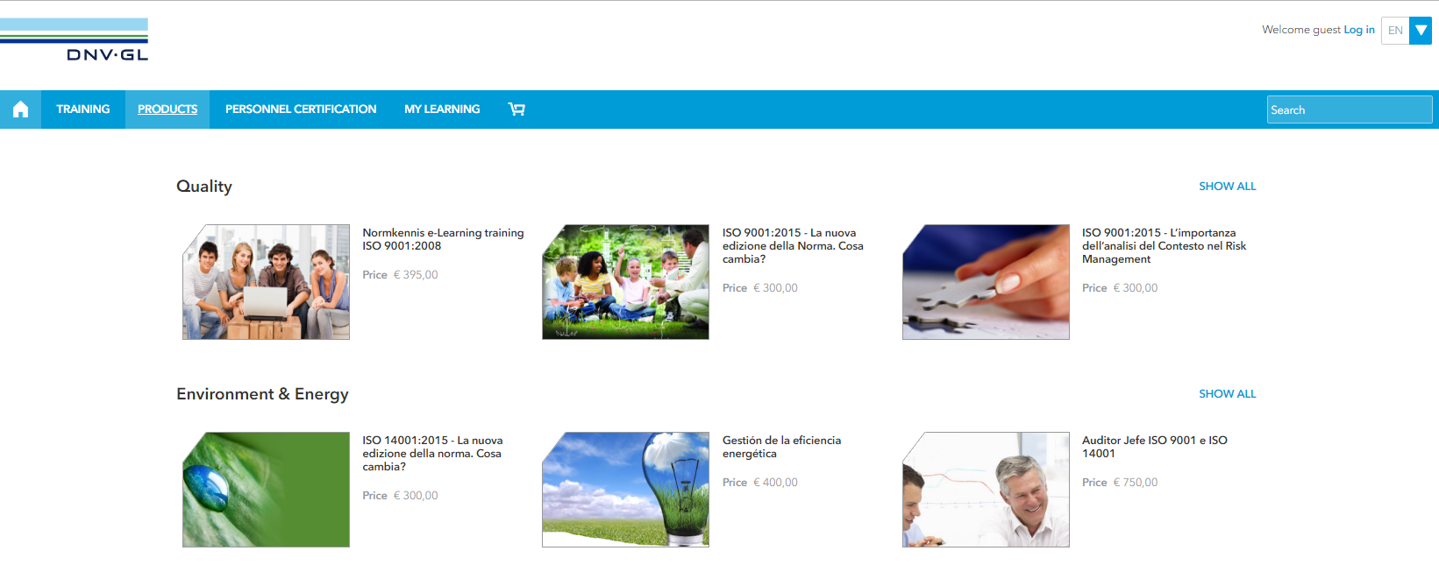

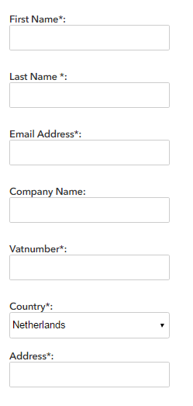
Then, click Register, and fill the form.
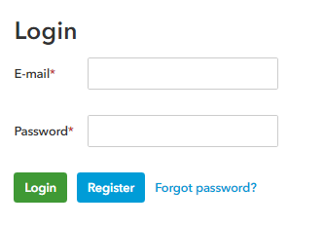

Once all the information has been provided click Submit.

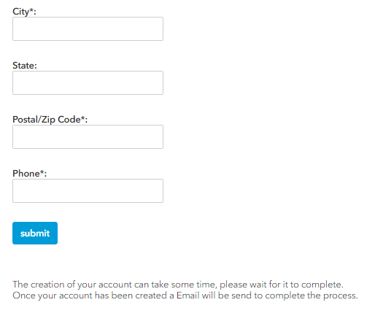
- You will receive in the email given an email from My DNV GL, with a link so you can continue with your registration.

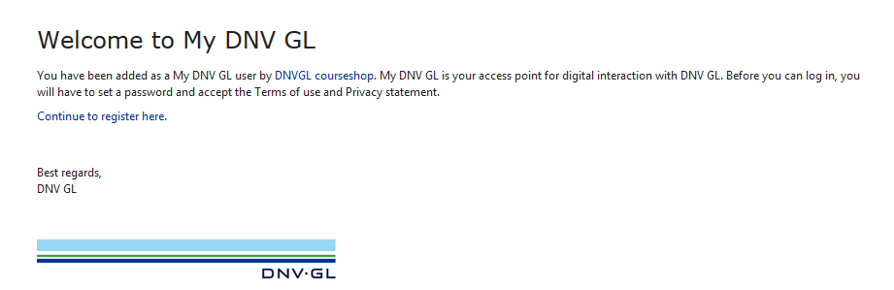

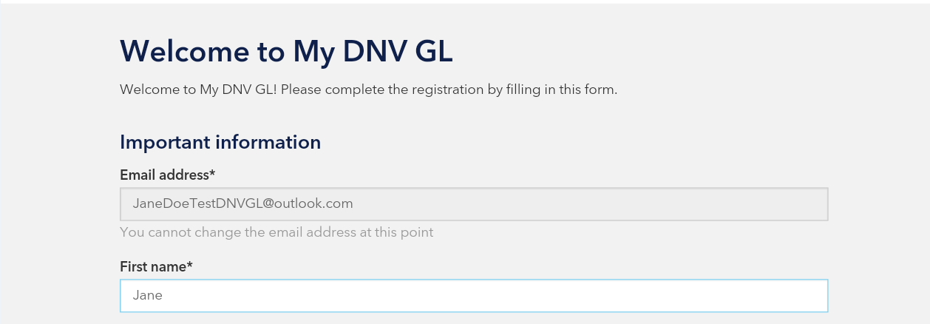
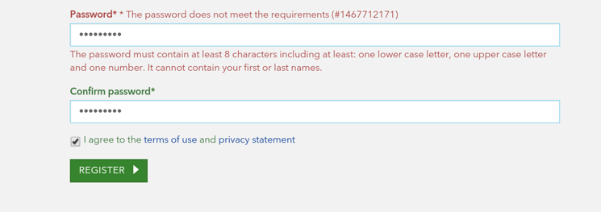
It is really important that the password meets the requirements:
- Must contain at least 9 characters
- Must contain one lower case letter
- Must contain one upper case letter
- Must contain at least one number

Now your registration is completed and you can access our training services.

HOW CAN I BUY A COURSE?

- Access our webshop https://elearning.dnvgl.com/webshop/ , click log in and use the information that you have used before when creating the account.
- Choose the course that you would like to take.
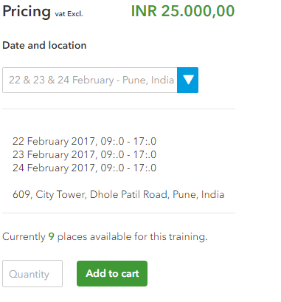

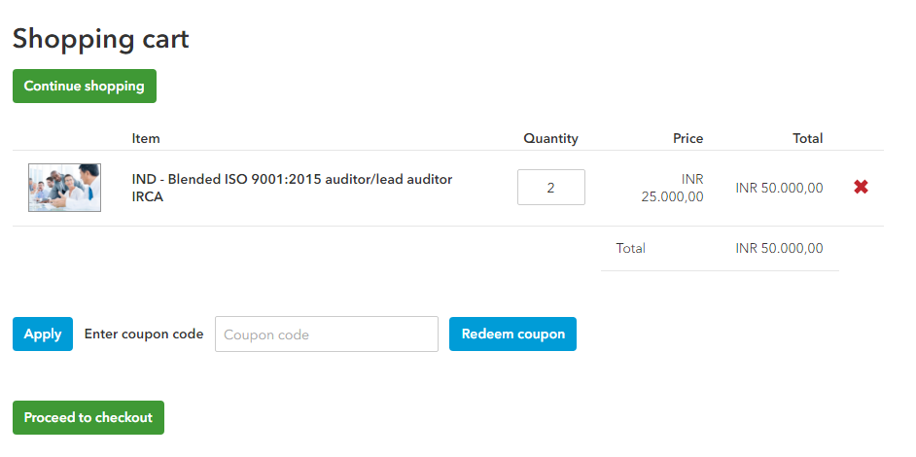

You will need to fill in the form with your invoicing details.
Don’t forget to read our Terms of use (you will need to stroll down completely), and click the button I have read and accept the Payment Terms and conditions.
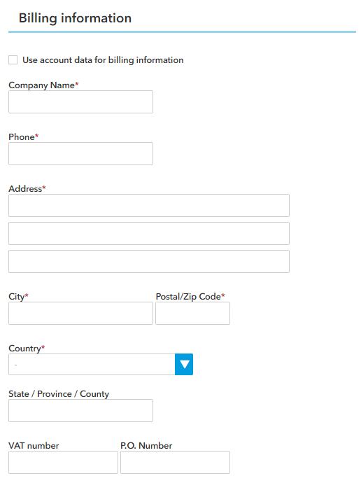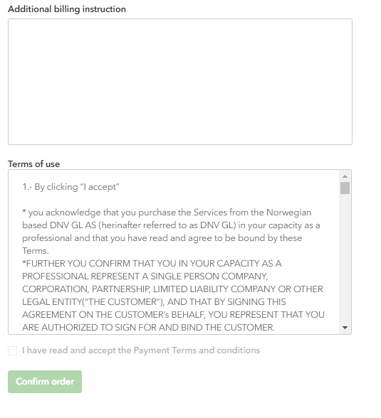

Once you have confirmed the order you will be able to download a document with the class details and the amount.

- The order is already confirmed and that information can be found under My Orders.
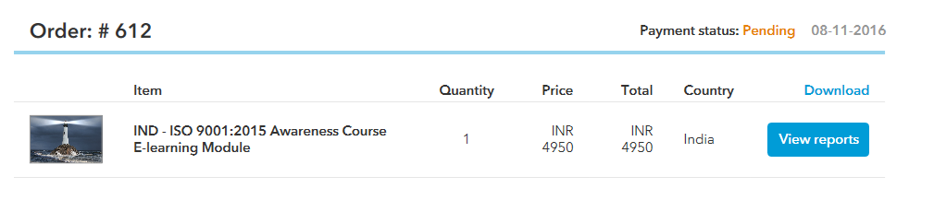

An automated email will be received in your email address confirming the reception of your registration form.
Once the course has been approved, you will receive a second email letting you know that you can make the payment for the course.
Please once the transfer has been made send us the receipt for our control at training-baindia@dnvgl.com and shortly, you will receive your personal voucher code to access Moodle.
You can also check the status of your order from our webshop.
Click View reports to get your voucher code.
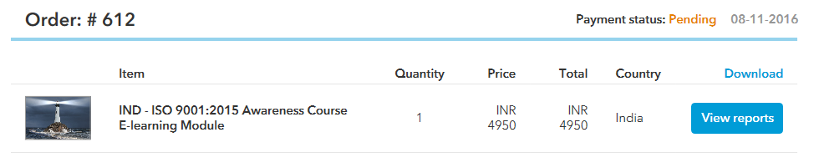

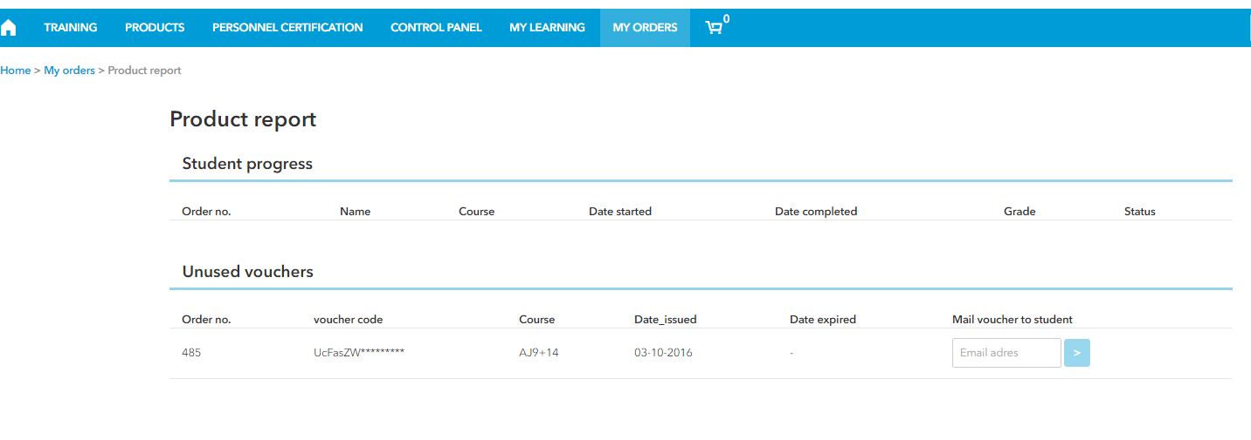
Now you just need to insert your email or the email address of the personal who will be taking the course and click the arrow. Please be aware that once the email has been sent the voucher code number will disappear and you won’t be able to get it back, so please double check the email address.

Below an example of the Access voucher that you will receive:
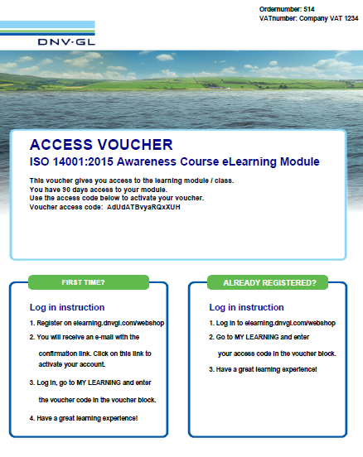
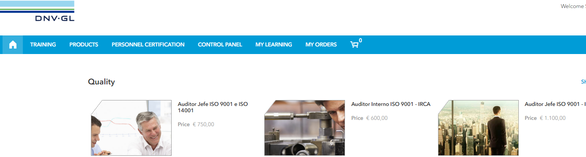

You will be redirected to our Moodle platform:
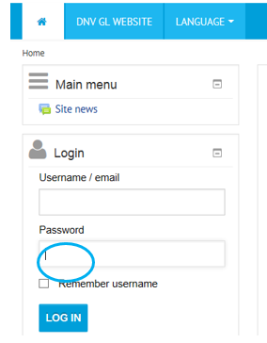
Introduce your email and password, the same ones that you used in the webshop, and then, Log in.
In the following tab you can introduce the voucher code received:
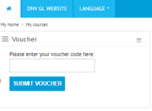

Now you will be able to access your course.

